

Semester Two Examination, 2016

Question/Answer Booklet

MATHEMATICS

SOLUTIONS
SPECIALIST
UNITS 1 AND 2

Section Two:

Calculator-assumed

Student Number: In figures

In words

Your name

Time allowed for this section
Reading time before commencing work: ten minutes
Working time for section: one hundred minutes

Materials required/recommended for this section
To be provided by the supervisor
This Question/Answer Booklet
Formula Sheet (retained from Section One)

To be provided by the candidate
Standard items: pens (blue/black preferred), pencils (including coloured), sharpener, correction fluid/tape, eraser, ruler, highlighters

Special items: drawing instruments, templates, notes on two unfolded sheets of A4 paper, and up to three calculators approved for use in the WACE examinations

Important note to candidates
No other items may be taken into the examination room. It is your responsibility to ensure that you do not have any unauthorised notes or other items of a non-personal nature in the examination room. If you have any unauthorised material with you, hand it to the supervisor before reading any further.

Structure of this paper

Section | Number of questions available | Number of questions to be answered | Working  time (minutes) | Marks available | Percentage of exam
Section One:  Calculator-free | 7 | 7 | 50 | 51 | 35
Section Two:  Calculator-assumed | 13 | 13 | 100 | 98 | 65
 |  |  | Total | 149 | 100

Instructions to candidates

1. The rules for the conduct of examinations are detailed in the school handbook. Sitting this examination implies that you agree to abide by these rules.

2. Write your answers in this Question/Answer Booklet.

3. You must be careful to confine your response to the specific question asked and to follow any instructions that are specified to a particular question.

4. Spare pages are included at the end of this booklet. They can be used for planning your responses and/or as additional space if required to continue an answer.
- Planning: If you use the spare pages for planning, indicate this clearly at the top of the page.
- Continuing an answer: If you need to use the space to continue an answer, indicate in the original answer space where the answer is continued, i.e. give the page number. Fill in the number of the question that you are continuing to answer at the top of the page.

5. Show all your working clearly. Your working should be in sufficient detail to allow your answers to be checked readily and for marks to be awarded for reasoning. Incorrect answers given without supporting reasoning cannot be allocated any marks. For any question or part question worth more than two marks, valid working or justification is required to receive full marks. If you repeat any question, ensure that you cancel the answer you do not wish to have marked.

6. It is recommended that you do not use pencil, except in diagrams.

7. The Formula Sheet is not to be handed in with your Question/Booklet.

Section Two: Calculator-assumed 65% (98 Marks)
This section has thirteen (13) questions. Answer all questions. Write your answers in the spaces provided.

Working time for this section is 100 minutes.

Question 8 (5 marks)
Points B, C and E lie on the circle with diameter AOD as shown below. $∠ABC=115°$, $∠BAC=20°$ and $∠ACE=60°$.
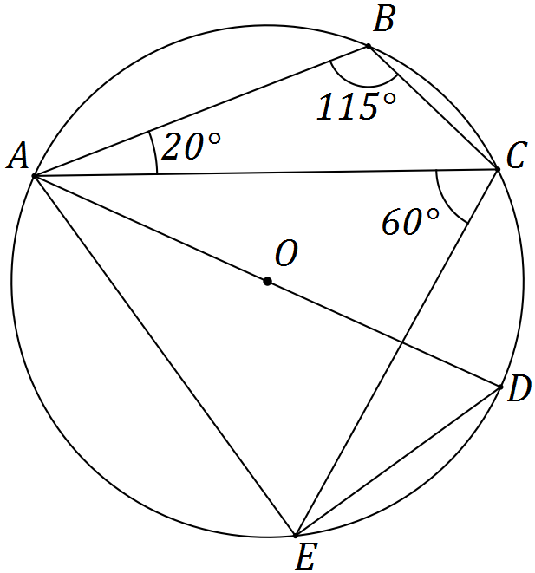

Determine the size of the following angles.

(a) $∠ADE$. (1 mark)
Solution
$60°$
Specific behaviours
states angle

(b) $∠EAD$. (1 mark)
Solution
$30°$
Specific behaviours
states angle

(c) $∠AEC$. (1 mark)
Solution
$65°$
Specific behaviours
states angle

(d) $∠CAD$. (1 mark)
Solution
$25°$
Specific behaviours
states angle

(e) $∠CED$. (1 mark)
Solution
$25°$
Specific behaviours
states angle

Question 9 (7 marks)
(a) $ABCDEF$ is a regular hexagon. The midpoint of side $DE$ is $M$.

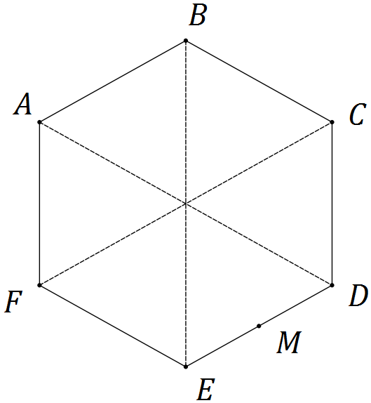

Let $a=\vec{AB}$ and $b=\vec{AF}$. Express each of the following in terms of a and b.

(i) $\vec{BC}$. (1 mark)
Solution
$\vec{BC}=a+b$
Specific behaviours
states correct expression

(ii) $\vec{AE}$. (1 mark)
Solution
$\vec{AE}=\vec{AF}+\vec{FE}=b+(a+b)=a+2b$
Specific behaviours
states correct expression

(iii) $\vec{MB}$. (1 mark)
Solution
$\vec{MB}=\vec{ME}+\vec{BE}=-0.5a-2b$
Specific behaviours
states correct expression

(b) Three forces, $F_{1}$, $F_{2}$ and $F_{3}$ act on a body that remains in equilibrium.

$F_{1}$ has a magnitude of 400 N. The angle between the directions of $F_{1}$ and $F_{2}$ is 150°, between $F_{1}$ and $F_{3}$ is 135° and between $F_{2}$ and $F_{3}$ is 75°.

Determine the magnitudes of $F_{2}$ and $F_{3}$, rounding your answers to the nearest whole number. (4 marks)
Solution
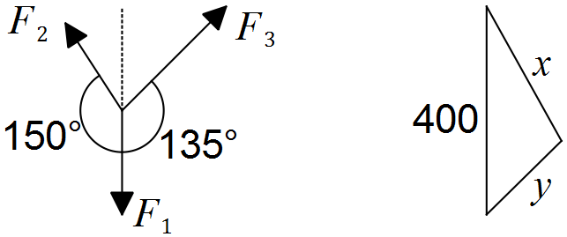

For equilibrium, $F_{1}+F_{2}+F_{3}=0$ - nose to tail vectors in triangle.

If magnitudes of $F_{2}=x$ and $F_{3}=y$ then $\frac{x}{\sin{45}}=\frac{y}{\sin{30}}=\frac{400}{\sin{105}}$

Solving gives $x=F_{2}=293$ N and $y=F_{3}=207$ N.

Specific behaviours
sketch diagram
triangle or equation indicates force vectors must sum to zero
solves for $x$
solves for $y$

Question 10 (7 marks)
(a) A number is to be formed by randomly selecting three different digits from those in the number 93265. Determine how many different numbers

(i) start with an odd digit. (1 mark)
Solution
$3×4×3=36$ numbers

Specific behaviours
calculates correct number

(ii) end with an even digit. (1 mark)
Solution
$2×4×3=24$ numbers

Specific behaviours
calculates correct number

(iii) start with an odd digit or end in an even digit. (2 marks)
Solution
$3×2×3=18$ numbers start with an odd digit and end in an even digit
$36+24-18=42$ numbers

Specific behaviours
calculates set intersection
calculates correct number for set union

(b) A computer user has forgotten their six character, case-sensitive password, but know that they always use a permutation of F, F, 1, 9, 9, and 9 - their initials and the year they were born. Determine how many passwords are possible if

(i) the F's must both be uppercase. (2 marks)
Solution
$\frac{6!}{2!×3!}=\frac{6×5×4}{2}=60$ passwords

Specific behaviours
shows correct method
calculates correct number

(ii) either F can be lowercase or uppercase. (1 mark)
Solution
FF can be replaced with Ff, fF or ff, so $4×60=240$ passwords

Specific behaviours
calculates correct number

Question 11 (8 marks)
(a) Triangle BCE is such that B, C and E lie on a circle with centre O and radius 29 cm. Diameter AD and chord CE intersect at F, so that $DF=8.5$ cm and $EF=25.5$ cm.
Determine the lengths OF, CF and BC. (5 marks)

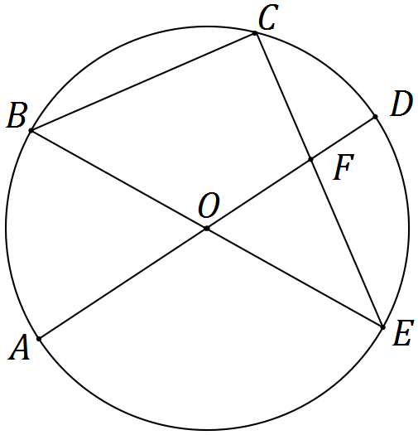

Solution
$OF=29-8.5=20.5$ cm

$CF×EF=DF×AF⇒CF=8.5×\frac{29+20.5}{25.5}=16.5$ cm

$ΔBCE$ is right-angled $⇒BC=\sqrt{{\left(29+29\right)}^{2}-{\left(16.5+25.5\right)}^{2}}=40$ cm

Specific behaviours
calculates OF
uses intersecting chord theorem
calculates CF
uses angle in semicircle
calculates BC

(b) In the diagram below, points B, C and D lie on a circle with centre O. The tangents to the circle at B and D intersect at point A. If $∠BAD=x$, prove that $∠BCD=90°-\frac{x}{2}$. (3 marks)

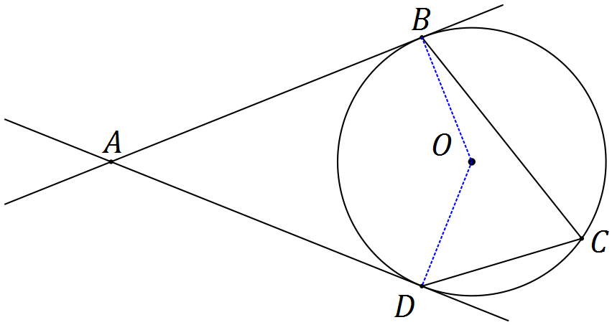
Solution
In quadrilateral ABOD, $∠ABO=∠ADO=90°$ (tangent-radius angle)

$∠BOD=360-90-90-x=180-x$ (angle sum in quadrilateral)

$∠BCD=\frac{1}{2}×∠BOD=\frac{1}{2}×180-x=90°-\frac{x}{2}$ (angle at centre twice that on circ.)

Specific behaviours
adds radii to diagram noting right-angles
determines $∠BOD$ with reason
determines $∠BCD$ with reason

Question 12 (9 marks)
Transformation A is an anti-clockwise rotation about the origin of 90° and matrix $B=\left[\begin{matrix}2 & 0 \\ 0 & 3\end{matrix}\right]$.

(a) Represent transformation A as a $2×2$ matrix. (2 marks)
Solution
$$A=\left[\begin{matrix}0 & -1 \\ 1 & 0\end{matrix}\right]$$

Specific behaviours
writes matrix for 90° rotation
matrix is for anticlockwise rotation

(b) Describe the transformation represented by matrix B. (2 marks)
Solution
A dilation parallel to x-axis of scale factor 2 and dilation parallel to y-axis of scale factor 3.

Specific behaviours
two dilations
fully qualifies both dilations with directions and scale factors

(c) Determine the coordinates of the point $P(-15, -11)$ following transformation A and then transformation B. (2 marks)
Solution
$$P^{'}=\left[\begin{matrix}2 & 0 \\ 0 & 3\end{matrix}\right]×\left[\begin{matrix}0 & -1 \\ 1 & 0\end{matrix}\right]×\left[\begin{matrix}-15 \\ -11\end{matrix}\right]$$
$$=\left[\begin{matrix}2 & 0 \\ 0 & 3\end{matrix}\right]×\left[\begin{matrix}11 \\ -15\end{matrix}\right]=\left[\begin{matrix}22 \\ -45\end{matrix}\right]$$

Specific behaviours
calculates first image using A
calculates $P'$

(d) Following transformation B and then transformation A, point Q is transformed to point $Q'(12, 7)$.

Determine the single matrix that will transform $Q'$ back to $Q$ and hence determine the coordinates of point Q. (3 marks)

Solution
$$Q^{'}=ABQ⇒Q=B^{-1}A^{-1}Q' \\ B^{-1}A^{-1}=\left[\begin{matrix}\frac{1}{2} & 0 \\ 0 & \frac{1}{3}\end{matrix}\right]×\left[\begin{matrix}0 & 1 \\ -1 & 0\end{matrix}\right]=\left[\begin{matrix}0 & \frac{1}{2} \\ -\frac{1}{3} & 0\end{matrix}\right] \\ Q=\left[\begin{matrix}0 & \frac{1}{2} \\ -\frac{1}{3} & 0\end{matrix}\right]×\left[\begin{matrix}12 \\ 7\end{matrix}\right]=\left[\begin{matrix}3.5 \\ -4\end{matrix}\right]$$

Specific behaviours
determines inverse of B and inverse of A
determines single matrix
determines coordinates of Q

Question 13 (8 marks)
(a) On the axes below sketch the graph of $y=\frac{1}{2}\sec\left(x-\frac{π}{2}\right)$. (3 marks)

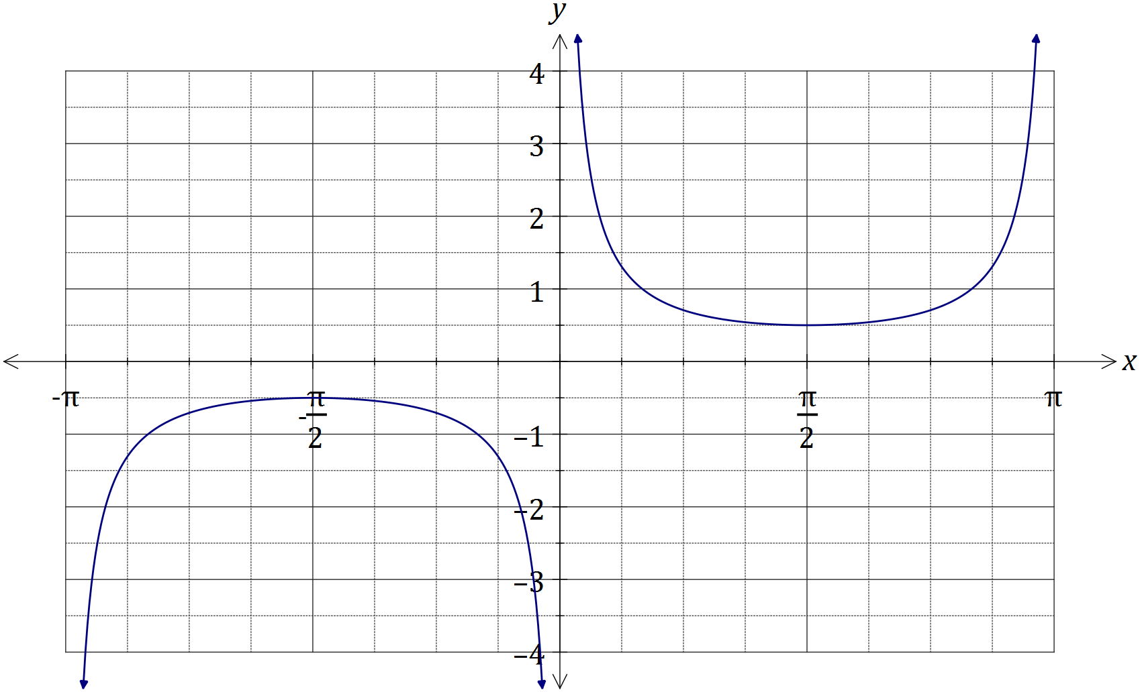
Solution
See graph
Specific behaviours
max/min correct locations
vertical asymptotes
smooth curves

(b) Consider the function $f\left(t\right)=2\sin{t}-5\cos{t}$, $t≥0$.

(i) $f\left(t\right)$ can be expressed in the form $r\sin{(t-α)}$, where $r>0$ and $0≤α≤\frac{π}{2}$. Determine the values of $r$ and $α$, rounded to 2 decimal places. (3 marks)
Solution
$$2\sin{t}-5\cos{t}= r\sin{(t-α)} \\ =r\sin{t}\cos{α}-r\cos{t}\sin{α}$$
$r\cos{α}=2$ and $r\sin{α}=5$ $⇒r=\sqrt{29}≈5.39$, $α=\tan^{-1}{\frac{5}{2}}≈1.19$

Specific behaviours
uses difference identity
determines r
determines $α$

(ii) Hence or otherwise determine the minimum value of $f(t)$ and the smallest value of t for this minimum to occur. (2 marks)
Solution
Minimum value is $-\sqrt{29}$
Occurs when $t-\tan^{-1}{\frac{5}{2}}=\frac{3π}{2}⇒t≈5.90$

Specific behaviours
states minimum value
determines first time, $t≥0$

Question 14 (8 marks)
(a) Consider the vectors $p=(24, -143)$ and $q=(20, -21)$. Determine

(i) the angle between the directions of vectors p and q. (1 mark)
Solution
Using CAS, angle is 34.1°

Specific behaviours
states correct angle.

(ii) two vectors that are perpendicular to q and have the same magnitude as p.
(3 marks)
Solution
Magnitude of required vectors are $\left|p\right|=145$

Unit vectors $⊥$ to q are $±\frac{1}{29}\left(21, 20\right)$

Required vectors are $±\frac{145}{29}×\left(21, 20\right)=\left(105, 100\right)$ and $(-105, -100)$

Specific behaviours
calculates magnitudes of p and q
determines at least one perpendicular vector
states both required vectors

(b) If $\vec{AB}=(3, 4)$ and $\vec{AC}=(-2, 1)$, determine

(i) the component of $\vec{AB}$ parallel to $\vec{AC}$. (2 marks)
Solution
Vector projection of $\vec{AB}$ on $\vec{AC}$:
$$\frac{\left(3, 4\right)⋅\left(-2, 1\right)}{\left(-2, 1\right)⋅\left(-2, 1\right)}×\left(-2, 1\right)=(0.8,-0.4)$$

Specific behaviours
substitutes correctly into vector projection formula
evaluates component

(ii) the component of $\vec{AB}$ perpendicular to $\vec{AC}$. (2 marks)
Solution
Let component be r.
$$r+\left(0.8, -0.4\right)=\vec{AB} \\ r=\left(2.2, 4.4\right)$$

Specific behaviours
shows use of vector addition
evaluates component

Question 15 (8 marks)
(a) Express the recurring decimal $1.1\overline{58}$ as a rational number. (2 marks)
Solution
Let $x=1.158585858585…$ then $100x=115.858585858…$
So $100x-x=99x=114.7⇒x=\frac{1147}{990}$

Specific behaviours
multiplies by 100
expresses as rational number in lowest terms

(b) Use a counterexample to explain why the statement $(∀x∈Z)(∃y∈Z)(2xy=24)$ is false.
(2 marks)
Solution
If $x=24$, then$y=\frac{1}{2}$ and so statement is false, as an integer value for $y$ clearly does not exist for all values of $x$.

Specific behaviours
counterexample
explanation

(c) Prove, by contradiction, that $\sqrt{6}$ is irrational. (4 marks)
Solution
Assume that $\sqrt{6}$ is rational and can be expressed in the form $\frac{a}{b}$ where a and b are both integers with no common factors.

Then 6$=\frac{a^{2}}{b^{2}}⇒a^{2}=6b^{2}=2(3b^{2})$, so that $a^{2}$ and hence a must be even.

If $a=2k$ (k an integer) then ${\left(2k\right)}^{2}=6b^{2}⇒{3b}^{2}=2k^{2}$, so that $3b^{2}$ and hence $b^{2}$ and b must also be even.

But if both a and b are multiples of 2, this contradicts the original assumption, which means it is false and so $\sqrt{6}$ is not rational, and so must be irrational.

Specific behaviours
clearly makes rational assumption
deduces that a must be even
deduces that b must be even
explains contradiction

Question 16 (7 marks)
(a) Let the angle $θ=\frac{π}{3}-\frac{π}{4}=\frac{π}{12}$.

(i) Use your calculator to write down an exact value for $\sin\left(\frac{π}{12}\right)$. (1 mark)
Solution
$\frac{\sqrt{2}\left(\sqrt{3}-1\right)}{4}=\frac{\sqrt{6}-\sqrt{2}}{4}$

Specific behaviours
writes an exact value

(ii) Use an angle sum or difference identity to show how to obtain the above exact value for $\sin\left(\frac{π}{12}\right)$. (3 marks)
Solution
$$\sin\left(\frac{π}{3}-\frac{π}{4}\right)=\sin\left(\frac{π}{3}\right)\cos\left(\frac{π}{4}\right)-\cos\left(\frac{π}{3}\right)\sin\left(\frac{π}{4}\right) \\ =\frac{\sqrt{3}}{2}×\frac{\sqrt{2}}{2}-\frac{1}{2}×\frac{\sqrt{2}}{2} \\ =\frac{\sqrt{6}-\sqrt{2}}{4}$$

Specific behaviours
uses difference identity
shows substitution of four correct values
shows simplification

(b) Prove the identity $\sin{x}+\sin{2x}+\sin{3x}=\left(1+2\cos{x}\right)\sin{2x}$. (3 marks)
Solution
$$RHS=\left(1+2\cos{x}\right)\sin{2x} \\ =\sin{2x}+2\sin{2x}\cos{x} \\ =\sin{2x +\sin\left(2x+x\right)+sin\left(2x-x\right)} \\ =\sin{x}+\sin{2x}+\sin{3x} \\ =LHS$$

Specific behaviours
expands RHS
uses product as sum and difference
completes proof in logical steps

Question 17 (9 marks)
Trapezium OPQR has parallel sides PQ and OR such that $\left|\vec{OR}\right|=k|\vec{PQ}|$. Let $\vec{OP}=a$ and $\vec{PQ}=b$.

(a) Sketch the trapezium. (1 mark)
Solution
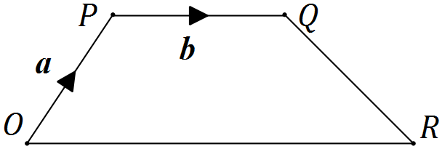
Specific behaviours
draws labelled trapezium

(b) Determine vectors for $\vec{OQ}$ and $\vec{PR}$ in terms of $k$, a and b. (2 marks)

Solution
$\vec{OQ}=a+b$ and $\vec{PR}=kb-a$.

Specific behaviours
states first vector
states second vector

(c) Show that the scalar product of $\vec{OQ}$ and $\vec{PR}$ is $k{\left|b\right|}^{2}-{\left|a\right|}^{2}+\left(k-1\right)a⋅b$. (2 marks)
Solution
$$\left(a+b\right)⋅\left(kb-a\right)=ka⋅b-a.a+kb.b-a.b \\ =k{\left|b\right|}^{2}-{\left|a\right|}^{2}+\left(k-1\right)a⋅b$$

Specific behaviours
expands scalar product
simplifies scalar product

(d) Simplify your result from (c) if $k=1$, $a=i+4j$ and $b=3i-2\sqrt{2}j$. (2 marks)

Solution
$$k{\left|b\right|}^{2}-{\left|a\right|}^{2}+\left(k-1\right)a⋅b={\left|b\right|}^{2}-{\left|a\right|}^{2}+\left(1-1\right)a⋅b \\ =\left(9+8\right)-\left(1+16\right)+0 \\ =0$$

Specific behaviours
substitutes $k=1$ to eliminate $a⋅b$
determines magnitudes and simplifies expression to zero

(e) Explain the geometric significance of your result from (d). (2 marks)
Solution
The values of k, a and b have turned the trapezium into a rhombus and as the scalar product is zero, the diagonals must intersect at right angles.

Specific behaviours
identifies significance of values
uses scalar product to conclude that diagonals intersect at right angles

Question 18 (7 marks)
(a) The work done, in joules, by a force F Newtons in changing the displacement of an object s metres is given by the scalar product of F and s. Calculate the work done when a force of 750 N moves an object a distance of 85 cm at an angle of 5° to the force.
(2 marks)
Solution
$750×0.85×\cos{5°}=635.1$ N

Specific behaviours
substitutes correct values into scalar product
evaluates work done

(b) A drone flies with a constant velocity and height above level ground, over which a wind blows from the north west at 3.5 metres per second. After 15 seconds, the drone reaches a point 85 metres on a bearing of 020° from where it was launched. Determine the velocity of the drone, giving its magnitude to two decimal places and bearing to the nearest degree. (5 marks)
Solution
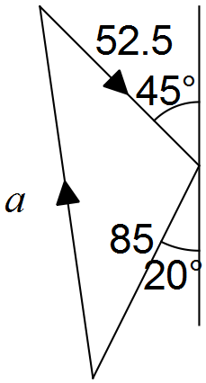

Wind component is $15×3.5=52.5$ m

$a^{2}={52.5}^{2}+{85}^{2}-2\left(52.5\right)\left(85\right)\cos{115}⇒a=117.2737$

Speed of drone is $117.2737÷15=7.82$ m/s (2dp).

$\frac{52.5}{\sin{x}}=\frac{106.4211}{\sin{115}}⇒x=24°$ and so bearing is $020-24=356°$.

Specific behaviours
sketch displacement vector diagram
uses cosine rule to determine drone displacement
calculates drone speed
uses sine rule to determine angle
determines bearing

Question 19 (8 marks)
(a) A high school has 5 male and 9 female volunteers from which to choose a debating team of 5 students. Determine the number of different teams that can be formed if

(i) there are no special requirements. (1 mark)
Solution
$\left(\begin{matrix}14 \\ 5\end{matrix}\right)=2002$ teams

Specific behaviours
evaluates correct number

(ii) there must be a captain and a vice-captain. (2 marks)
Solution
$\left(\begin{matrix}14 \\ 1\end{matrix}\right)×\left(\begin{matrix}13 \\ 1\end{matrix}\right)×\left(\begin{matrix}12 \\ 3\end{matrix}\right)=40040$ teams

Specific behaviours
shows a suitable method
evaluates correct number

(iii) there must be more females than males, but at least one male. (2 marks)
Solution
$\left(\begin{matrix}5 \\ 1\end{matrix}\right)×\left(\begin{matrix}9 \\ 4\end{matrix}\right)+\left(\begin{matrix}5 \\ 2\end{matrix}\right)×\left(\begin{matrix}9 \\ 3\end{matrix}\right)=1470$ teams

Specific behaviours
shows a suitable method
evaluates correct number

(b) Determine how many different numbers must be selected from the first 25 positive integers to be certain that at least one of them will be twice the other. (3 marks)
Solution
Partition integers into pigeonholes, where double included if possible:

{1, 2}, {3, 6}, {4, 8}, {5, 10}, {7, 14}, {9, 18}, {11, 22}, {12, 24},
{13}, {15}, {16}, {17}, {19}, {20}, {21}, {23}, {25}.

NB Other partitions possible.

There are 17 partitions (pigeonholes) and so 18 numbers (pigeons) are required to ensure that at least one will be twice the other.

Specific behaviours
partitions most integers
systematically partitions all integers
applies pigeonhole principle to get correct number

Question 20 (7 marks)
In the diagram below, the tangents from point A touch the circle at B and F. Point E lies on the major arc BF and D lies on BF so that $DE⊥BF$. Points C and G lie on AB and AF extended respectively such that $EC⊥AC$ and $EG⊥AG$.
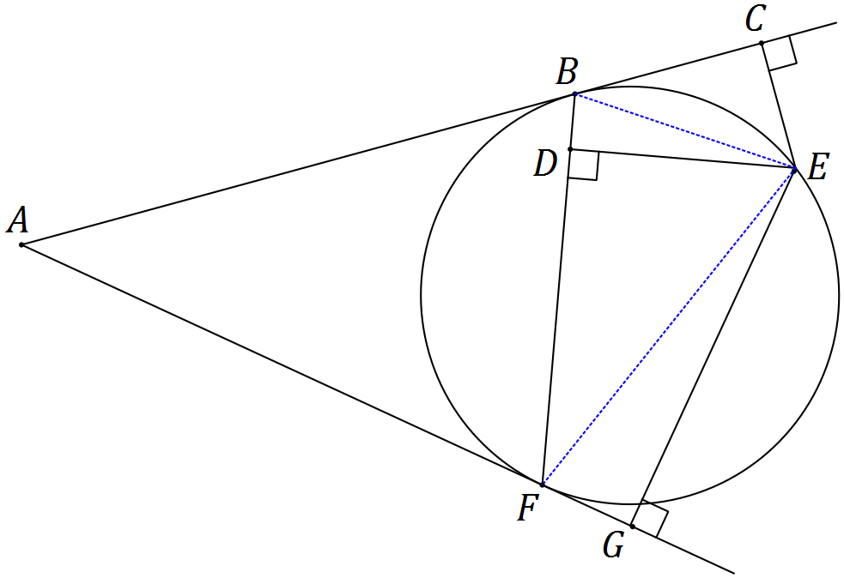

(a) Show that $ΔBCE$ and $ΔFDE$ are similar. (3 marks)
Solution
$∠CBE=∠DFE$ (alternate segment theorem)

$∠BCE=∠FDE$ (both right)

Hence $ΔBCE∼ΔFDE$ (AA)

Specific behaviours
shows one pair of angles equal with reason
shows second pair of angles equal with reason
makes conclusion that similar

(b) Show that $DE^{2}=CE×GE$. (4 marks)
Solution
$∠GFE=∠DBE$ (alternate segment theorem)
$∠BDE=∠FGE$ (both right)
Hence $ΔBDE∼ΔFGE$ (AA)

So ratio of sides is $\frac{DE}{GE}=\frac{BE}{FE}$

But ratio of sides from (a) is $\frac{CE}{DE}=\frac{BE}{FE}⇒\frac{CE}{DE}=\frac{DE}{GE}⇒DE^{2}=CE×GE$.

Specific behaviours
realises second pair of similar triangles required
uses same reasoning from (a) to show $ΔBDE∼ΔFGE$
states ratio of corresponding sides for both pairs of triangles
uses common ratio to obtain result

Additional working space

Question number: _________

© 2016 WA Exam Papers. Narrogin Senior High School has a non-exclusive licence to copy and communicate this paper for non-commercial, educational use within the school. No other copying, communication or use is permitted without the express written permission of WA Exam Papers.

